**Task 1: HDFS Commands**

**Test 1:** Create two directories on the bigdata user home page

Name the first ***datasource***, the second one ***datatarget***

hdfs dfs -mkdir /user/bigdata/datasource

hdfs dfs -mkdir /user/bigdata/datatarget

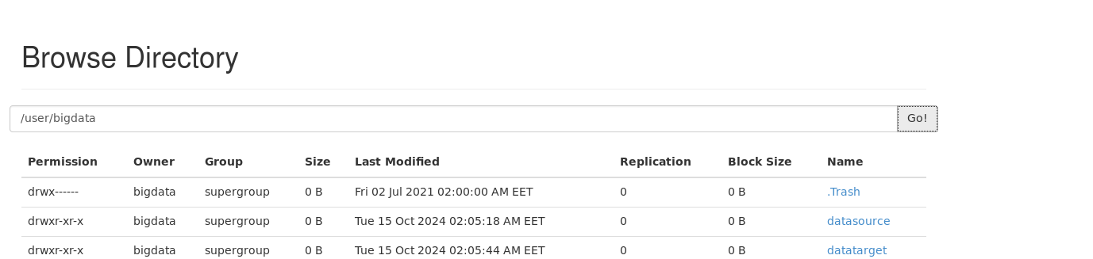

**Test 2**

Upload the two files (animals.txt and fruits.txt) to ***datasoure*** directory

hdfs dfs -put /home/bigdata/Desktop/animals.txt /user/bigdata/datasource

hdfs dfs -put /home/bigdata/Desktop/fruits.txt /user/bigdata/datasource

**Test 3:**

Run the HDFS command to merge the two files (animals.txt and fruits.txt) in the hdfs and name the merged file to ***files.merge***

hdfs dfs -appendToFile animals.txt /user/bigdata/file.merge

 hdfs dfs -appendToFile fruits.txt /user/bigdata/file.merge

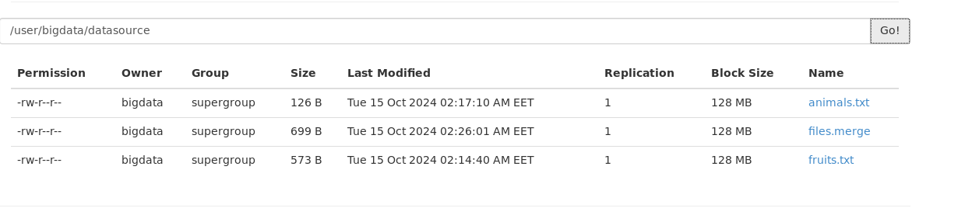

**Test 4:**

Copy the merged file from ***datasource***, the second one ***datatarget***

hdfs dfs -cp /user/bigdata/datasource/files.merge /user/bigdata/datatarget

**Test 5:.**

Modify the ***files.merge*** file permission to **full permission to owner only**

hdfs dfs -chmod 700 /user/bigdata/datatarget/files.merge

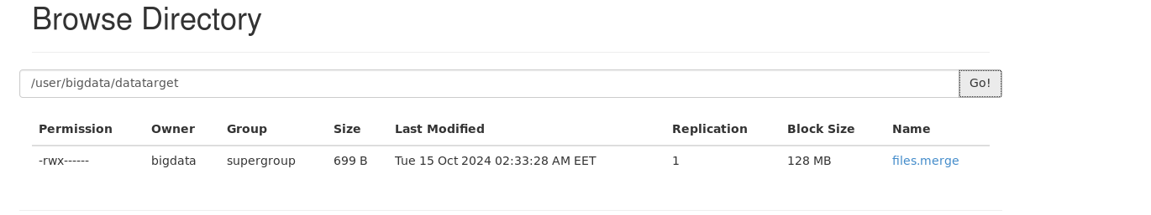

Test 6:.

Restoring a file from the trash in hdfs.

hdfs dfs -rm /user/bigdata/datasource/files.merge

hdfs dfs -mv /user/bigdata/.Trash/Current/user/bigdata/datasource/files.merge /user/bigdata/datasource

